At the Garden Gate

Teacher Booklet

Contents

Program Summary p. 3

Curriculum information p. 4

Information about Mugga-Mugga p. 6

Practical advice for planning your excursion
Checklist for planning your excursion p. 7
What will happen during the program? p. 9

Pre visit activities p. 10

Post visit activities p. 11

References p. 13

At the Garden Gate booking

Mugga-Mugga is an ideal venue to learn about how pioneer Australians lived in the past and how landscapes change over time. The program includes a tour of the cottage and paddocks after which students create a collage reflecting views from the property.

The following information is provided to assist teachers in making the most of their visit to Mugga-Mugga. Please note the checklist for planning your excursion is on page 7.

Name of Program | At the Garden Gate
Program Focus | To provide students with insight into the natural and human influenced landscape at Mugga-Mugga. Students will have an opportunity to learn about changes in the landscape and the links between the historic house and its increasingly urbanised setting.
Curriculum Focus | HASS F – 2: History and Geography sub strands  Knowledge and Understanding  - My personal world  - How my world is different from the past and can change in the future  - Our past and present connections to people and places  Inquiry and skills  - Questioning  - Researching  - Analysing  - Perspectives and interpretations  - Communicating  Visual Arts Band F -2
Program Objectives | To participate in an experiential, active learning program, with both indoor and outdoor components.
 | To increase understanding of the environmental and human interaction with the landscape.
 | To think about how student experiences are similar to or different from those of people in the past.
 | To interact with and explore an historic site.
Target Audience | Years Foundation - 2
Length of Program | 1 ½ - 2 hours
 | 4 hours if combined with Dawn’s Surprise
Availability of Program | Week 2 to week 9 of ACT school terms
Size of Group | 30 students maximum per program.  60 students maximum as a double program, combined with Dawn’s Surprise at Calthorpes’ House.  A ratio of 1 adult supervisor to 10 students is required.

Aim
The aim of At the Garden Gate is to encourage students to engage with Mugga-Mugga, both the house and the surrounding landscape. Engagement is active and hands on. A tour through the house and paddocks will enable students to recognise people’s lifestyles in the past and Mugga-Mugga’s increasingly urbanised setting. Students will investigate both the natural and human factors influencing changing landscapes and see the links between European settlement in the Canberra region and the present. Students will be able to explore interrelationships between, and changes to, social and natural environments, using Mugga-Mugga as a case study. They will communicate their experience through the creation of a collage.

Philosophy
The strategy used in this program is experiential discovery. The students are encouraged to engage with the site through hands-on activities: a tour through the house, an exploration of the paddock and the garden, and to create a collage made from both natural and manufactured materials. As a result of this strategy the responses of the group will influence the information that is provided at any specific point.
The main points and questions listed throughout the program should be viewed as a framework, a way to structure the central concepts of the program. However, it is possible that presenters will pick up on the mood of the group or an emerging theme and tease that out. The primary concern is that the students have an engaged learning experience that is both entertaining and informative.

Australian Curriculum: Humanities and Social Sciences

Key ideas:
Who we are, who came before us, and traditions and values that have shaped societies. The ways people, places, ideas and events are perceived and connected.

Knowledge and Understanding History sub-strand

Foundation: My personal world.
How the stories of families and the past can be communicated, for example through photographs, artefacts, books, oral histories, digital media, and museums (ACHASSK013)

Year 1: How my world is different from the past and can change in the future.
Differences in family structures and roles today, and how these have changed or remained the same over time (ACHASSK028)

How the present, past and future are signified by terms indicating time, as well as by dates and changes that have personal significance such as birthdays, celebrations and seasons (ACHASSK029)

Differences and similarities between students' daily lives and life during their parents’ and grandparents’ childhoods, including family traditions, leisure time and communications
(ACHASSK030)

Year 2: Our past and present connections to people and places.
The history of a significant person, building, site or part of the natural environment in the local community and what it reveals about the past (ACHASSK044)
How changing technology on people’s lives (at home and in the ways they worked, travelled communicated and played in the past) (ACHASSK 046)

Knowledge and understanding Geography sub-strand
Foundation:
The places people live in and belong to, their familiar features and why they are important to people (ACHASSK015)
The reasons why some places are special to people, and how they can be looked after (ACHASSK017)
Year 1:
The natural, managed and constructed features of places, their location, how they change and how they can be cared for (ACHASSK031)

Year 2:

The influence of purpose, distance and accessibility on the frequency with which people visit places (ACHASSK051)

Inquiry and Skills: Foundation – Year 2

Questioning
Pose questions about the past and present objects, people, places and events (ACHASSI001, ACHASSI18, and ACHASSI034)

Researching
Collect data and information from observations and identify information and data from sources provided (ACHASSI002, ACHASSI019, ACHASSI035)

Analysing
Explore a point of view (ACHASSI005, ACHASSI022, ACHASSI038)
Compare objects from the past and with those from the present and consider how places have changed over time. (ACHASSI006, ACHASSI023, ACHASSI039)
Evaluating and reflecting
Draw simple conclusions based on discussions, observations and information displayed in pictures and texts and on maps (ACHASSI008, ACHASSI024, ACHASSI041)
Communicating
Present narratives, information and findings in oral, graphic and written forms using simple terms to denote the passing of time and to describe direction and location (ACHASSI027, ACHASSI010, ACHASSI043)

Australian Curriculum: Visual Arts
Use and experiment with different materials, techniques, technologies and processes to make artworks (ACAVAM107)

Information about Mugga-Mugga

The following information provides an introduction to the historic property, Mugga-Mugga. This may be information you would like to share with your students in preparation for their visit.

Mugga-Mugga cottage was originally part of the 2,000 hectare Duntroon estate. Duntroon was established by Robert Campbell in 1827. You can still see Duntroon from the Mugga-Mugga paddocks. The Duntroon Estate stretched right across the plain.

Mugga-Mugga cottage was built in 1838 for Duntroon’s head shepherd. Several different families have lived in the cottage – all of them shepherds for the Duntroon Estate. Patrick Curley was the last Duntroon shepherd to live at the cottage.

Mr and Mrs Curley and their three daughters, Ada, Sylvia and Evelyn, moved to the cottage in 1913. Members of the Curley family lived in the cottage until 1985, when management of the property was handed over to the ACT Government. Sylvia Curley, the last surviving member of the family, died in 1999 aged 100. Sylvia Curley described the family’s arrival at Mugga-Mugga in August 1913 when she was fifteen years old:

We set out on our journey on a cold, wet, windy day in August. In addition to our pet magpie, who was a good talker, we had sheep dogs, horses, and our pony, and mother had purchased several head of roan shorthorn milking calves.

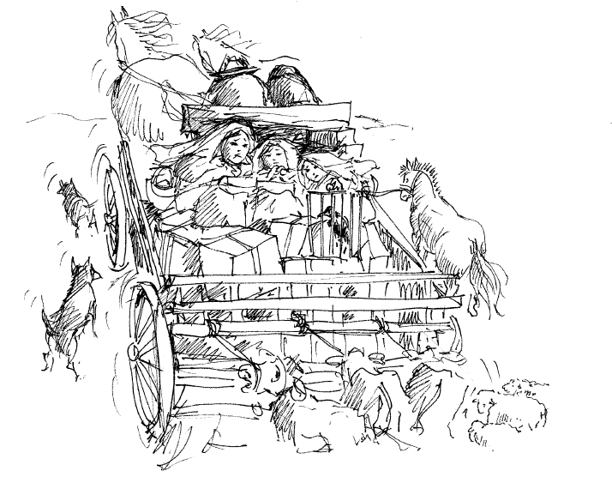

Checklist for planning your excursion

- Directions to Mugga-Mugga: Mugga-Mugga is located at 129 Narrabundah Lane, Symonston. Turn right off Jerrabomberra Ave onto Narrabundah Lane. Take the driveway on your right, immediately after Demeter, the olive grove. The driveway into Mugga-Mugga is signposted. The driveway is almost opposite a bus shelter, just beyond the entry to the Therapeutic Goods Administration site. This right-hand turn will take you through a gateway onto a dirt road. Follow the dirt road until you reach the first cattle grid. There is a wide gate to the right of the cattle grid. The bus must use this gate. If there are horses in the paddock the gate will be closed. Please close the gate once the bus has passed through in order to contain the livestock. Follow the road to the Education Centre and stop the bus before the cattle grid. When your students disembark please ensure that they do not walk across the cattle grid, but rather walk through the small gate on the left hand side.

- Clothing: Mugga-Mugga education programs are conducted both indoor and outdoor and include walking through paddocks. Warm, waterproof attire is important in the cooler months and sun protection is a priority throughout the year. Due to the possibility of snakes, insects and uneven terrain long pants and closed toed shoes are required. It is recommended visiting Teachers are familiar with the ACT Government Territory and Municipal Services Living with Snakes information, particularly the section Avoid being bitten, which can viewed at the following location: http://www.tams.act.gov.au/parks-recreation/plants_and_animals/urban_wildlife/local_wildlife/snakes
Mugga-Mugga retains the right to refuse entry to students who are inadequately dressed.

Additionally, can you please ensure that:
- You do not bring anyone with you who is unwell or displaying symptoms of COVID-19 including: fever, cough and shortness of breath.
- Use hand sanitiser we will provide onsite arrival, before and after eating, and before leaving the site.
- Your group is reminded of the importance of covering their mouth with their elbow when coughing and avoiding touching their face.
- Please make sure you have an accurate record of all students, teachers and carers in your group on file at school in the event of contract tracing requirements.

- Weather: Due to Covid 19 restrictions on indoor spaces we are unable to offer a wet weather alternative for this program. If wet weather is forecast we will contact you on the day before your excursion to discuss the options for postponement. If a severe fire danger rating is issued by ACT Emergency Services or a severe weather warning is issued by the Bureau of Meteorology the program will be cancelled by ACT Historic Places.

- Name tags: Please ensure that every student wears a name tag (first name only). This allows the presenters to communicate more effectively with the students.

- Preparation for the excursion: Divide the students into two groups before they leave school as there are two rotations in the program for At the Garden Gate.

- Meals: Students need to bring their own morning tea and lunch. Meals should be collected into a few tubs with lids. If undertaking a combined program with Calthorpes’ House lunch will be accommodated at Mugga-Mugga for both groups. There are no rubbish bins provided, so please take your rubbish away with you. It is recommended that students drink fluids during breaks.

- First Aid Kit: Please bring a First Aid Kit. Please note that our First Aid Kit does not include medications, nor can we supply equipment such as an EpiPen for allergic reactions. Please ensure you bring any medicines your students should require while they are at Lanyon.

- Specific Learning Needs: Please advise the Bookings Officer at the time of booking if there are students in your group with needs or access considerations including sight / hearing / physical / learning / allergies or who will be accompanied by a learning support assistant so staff can be prepared to assist in appropriate ways. The program is not easily wheelchair accessible; however, the program can be made more accessible by booking the Trailrider (an all terrain wheelchair) from Tidbinbilla Visitor Centre on 6205 1233. Please be aware that there are conditions to using the Trailrider. It is the school’s responsibility to book the Trailrider, attend training, provide sherpas, and arrange for the collection and return of the Trailrider.

- Numbers: Please confirm with the Education Officer the total number of students who attend the program on the day.

- Risk Management Plan: Please contact at historicplacesbookings@act.gov.au for a Risk Management Plan for this program.

What will happen during the program?

At the Garden Gate encourages students to engage with the Mugga-Mugga property through three activities: students tour the cottage, explore the paddock and create a collage.

Arrival: You will be greeted by a presenter at the gate to the Education Centre.
Please Note: it is important to ensure that your students do not cross the stock grid to reach the Education Centre: they must use the pedestrian gate.

During the program: The introduction to the program will begin at the Education Centre and then the group will be divided in half, both groups should have an accompanying adult and each group will do the same program in a different order.

There are two rotations, each of approximately twenty minutes:

The Cottage: Students will tour the cottage and consider the building materials, room function and objects, some of which illustrate the Curley family approach to reuse and recycling. Only the presenter will handle collection items, using gloves.

The paddock and garden: While visiting the paddock, each group will discuss the book, Window, by Jeannie Baker. This book introduces the concepts of urbanisation and collage. The children will also collect plant samples from the paddock to incorporate in a collage. The focus of this rotation is an examination of the different types of plants. Please note there are some safety rules that need to be observed in the garden and in the paddock. In addition to wearing appropriate clothing as mentioned above, students need to keep a safe distance from the horses; to not climb across rocky outcrops; and to remain in a group behind their presenter.

The two groups will come together at the Education Centre to carry out the final activity: making the collage. Students will use the plant samples they collected in the paddock, along with papers and other materials, to create their own view through a Mugga-Mugga window.
Pre visit activities

Read: At the Garden Gate uses a book by Jeannie Baker, Window, to introduce the concepts of collage and landscape change, and we recommend

As a class, you might also like to read other Jeannie Baker books:
- Circle. 2016
- Mirror. 2010
- Belonging. 2004.
- Home. 2004.
- The Hidden Forest. 2000.
- The Story of Rosy Dock. 1995.
- Where the Forest Meets the Sea. 1988.
- Home in the Sky. 1984.
- One Hungry Spider. 1982.
- Millicent. 1980.
- Grandmother. 1978.
- Grandfather. 1977.
- Polar. 1975

Visit Jeannie Baker’s website, http://www.jeanniebaker.com/index.htm, to find out more about her technique and other work.

Interactive digital tour: Peek inside the cupboards and drawers by viewing our Mugga-Mugga Cottage Digital Guide, free to download from iTunes. This interactive tour features a wealth of information to support your students’ understanding of this unique house museum, including music, voice recordings, and images of the cottage not accessible during learning programs.

Vocabulary: Create a class glossary of unfamiliar words the students might encounter on the program such as: landscape, museum, collection, collage, artwork, grassland, hessian, timber slab.

Location: Find a map of Canberra showing Mugga-Mugga. Locate points of interest including your school if you are located in Canberra, in order to help the students understand how to read the map. Show them where to read the suburb and street name. As a class, locate Lake Burley Griffin, Mugga-Mugga and the streets of children in the class. Point out the proximity of Mugga-Mugga to Canberra.

Compare the map to a historical map of Canberra. Appropriate maps and landscape views are avaliable at the following link, http://www.idealcity.org.au/competition-2-information_materials.html. These digitised images were sent to entrants of the Canberra design competion in 1911, just two years before the Curleys moved to Mugga-Mugga.

What has changed? Describe changes in the landscape of Canberra by comparing a recent map or photo to maps and photos from times in the past. What will the students see during the trip to Mugga-Mugga?
Observation: Ask the students to look outside a window at home. They may need to ask a parent to describe the changes that have occurred in their area. Write a story or create a mural to illustrate the changes, or predict changes. Resources for students to discover how their area has changed could include photographs, newspapers, and oral history interviews with their parents or grandparents.

Create: Collect different shaped leaf and bark types from around the school grounds or ask students to bring some from home. Using paper and charcoal, pencils or crayons, create rubbings that show the textures of the leaves and bark.

Post visit Activities

Create: Use clay and a rolling pin to make flat tiles, create textures by making impressions of natural and manufactured objects.

Action: Pot a native seedling in the interests of promoting biodiversity in cities or pot a vegetable seedling in the interests of promoting healthy gardens.

Revisit the cottage: Peek inside the cupboards and drawers by viewing our Mugga-Mugga Cottage Digital Guide, free to download from iTunes. This interactive tour features a wealth of information to support your students’ understanding of this unique house museum, including music, voice recordings, and images of the cottage not accessible during learning programs.

Eat: One of the canisters in the kitchen at Mugga-Mugga is for sago. What would it taste like? What are the health benefits? Where does it come from? Why don’t people tend to eat it anymore?

Chronology: To further explore the concept of change overtime create a class timeline of important events in the community of the class, the school or the city.

Record: Investigate ways to improve a garden in your school grounds, for example increase ground cover, reduce weeds, increase moisture in the soil, encourage birds into the area by planting suitable native plants, plant bush tucker, etc. Monitor the garden by taking photographs of the area at regular intervals over a 1-2 year period. Display the changes to the garden over time recorded in the images. Discuss the changes and make plans for further improvements.

Share: Ask students to bring in a ‘treasure’ they have found from nature and use these items for discovery and to inspire art, poetry or even creative movement.

Display: Stage your own exhibition of students’ work that responds to the Jeannie Baker book, Window, and the students’ experiences at Mugga-Mugga. The collages could be arranged in a variety of ways including surname, daytime and sunset.
Revision: These images could also serve as the basis for visual learning or a creative response in the form of a story or painting of the cottage.

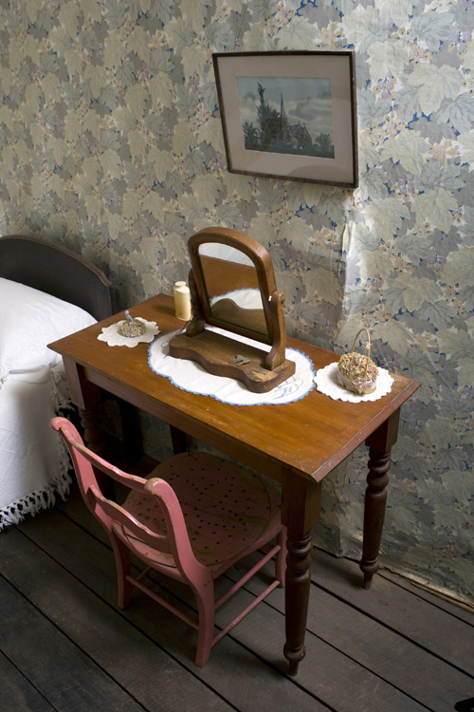
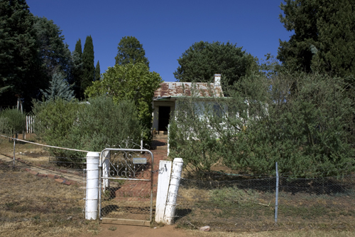

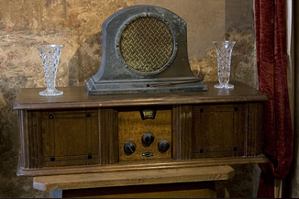

References

ACT Government. 2008. Hazard and OHS Risk Assessment Form: At the Garden Gate. Downloadable from
http://www.historicplaces.com.au/learning/at-the-garden-gate

Australian Curriculum and Assessment Reporting Authority. 2013. Australian Curriculum: History. Downloadable from:
http://www.australiancurriculum.edu.au/History/Rationale

Baker, Jeannie. 1991. Window. Walker Books Ltd, Sydney.

Baker, Jeannie. No date. Jeannie Baker. http://www.jeanniebaker.com/index.htm. Network Logic.

Curley, Sylvia. 1998. A Long Journey: Duntroon, Mugga-Mugga and three careers. ACT Government, Canberra.

Friends of Grasslands. 2008. http://www.fog.org.au/.

Johnston, Alexandra. 2004. Window and Belonging: CMAG Education Program.

Landlearn. 2008. ‘Window’ – by Jeannie Baker – a book activity. In curriculum activities for classroom use. Accessed 23 April 2008 from: http://www.landlearn.net.au/print/window.htm

Lawson, Elaine. 1996. Mugga, A Guide. ACT Government, Canberra.

MCEETYA. 2006. Statements of Learning for Civics and Citizenship. Curriculum Corporation, Carlton.

National Archives of Australia, National Capital Authority and the National Library of Australia. 1995. An Ideal City? The 1912 Competition to Design Canberra. Accessed 24 April 2008 from:
http://www.idealcity.org.au/competition-2-information_materials.html.

