Dawn’s Surprise

Teacher Booklet

Contents

Program Summary p. 3

Curriculum information p. 4

Information about Calthorpes’ House p. 6

Practical advice for planning your excursion
Checklist for planning your excursion p. 7
What will happen during the program? p. 8

Pre visit activity p. 9

Post visit activity p. 13

References p. 14

Dawn’s Surprise booking

Calthorpes’ House is a wonderful venue to learn about how people lived in the past. The house was built in 1927 and is significant for its substantially intact collection of objects from the period which, with the gardens, allows students to enter a time capsule. Exploring the house, in the footsteps of the seven year old Dawn Calthorpe, is a wonderful way for students to engage with the concept of how the past is different or similar to today.

The program includes a tour of the house and gardens. Students will also play old fashioned games.

The following information is provided to assist teachers in making the most of their visit to Calthorpes’ House. Please note the checklist for planning your excursion is on page 7.

Program Summary

Name of Program | Dawn’s Surprise
Program Focus | To provide students with an opportunity to learn about Calthorpes’ House through the eyes of a child – how did the seven year old Dawn Calthorpe live in the 1930s?  Children are encouraged to empathise with lives of children in the past by comparing Dawn’s life with their own life.
Curriculum focus | Historical Knowledge and Understandings  - Personal and family histories  - Present and past family life  - The past in the present  Historical skills  - Chronology, terms and concepts  - Historical questions and research  - Analysis and use of sources  - Perspectives and interpretations
Program objectives | To participate in an experiential, differentiated learning environment through discovery, hands-on, sensory, and interconnected experiences.  Through experimentation, practice and play children are encouraged to use their interest in people and how things work to make sense of their world.
Target Audience | Years Foundation - 2.
Length of Program | 1½ - 2 hours
Availability of Program | Tuesday, Wednesday, Thursday
Size of Group | 30 students maximum as a single program.  60 students maximum as a double program, combined with At the Garden Gate at Mugga-Mugga.  A ratio of 1 adult supervisor to 10 students is required.

Aim
The program explores the experience of the past through the eyes of a seven year old. The students are provided insight into the everyday experiences of children in the 1930’s through three activities: a tour of the house, the garden and playing old fashioned games. The engagement is active and hands on. The children will explore the similarities and differences between their lives and the lives of children in the past using Calthorpes’ House as a case study.

Philosophy
The strategy used in this program is experiential discovery. The students are encouraged to engage with the site through hands on activities. As a result of this strategy the response from the group will influence the information that is provided at any specific point. Each presenter should respond to the students in their group based on the themes of the program.

The main points and questions listed throughout the program should be viewed as a framework, a way to structure the central concepts of the program. However, it is possible that presenters will pick up on the mood of the group or an emerging theme and tease that out. The primary concern is that the students have an engaged learning experience that is both entertaining and informative.

Australian Curriculum: History
Key Concepts: Continuity and change, cause and effect, significance, perspectives, empathy.

Key Questions:
What stories do other people tell about the past?
How can stories of the past be told and shared?
How has family life changed or remained the same over time?
How can we show that the present is different from or similar to the past?
What aspects of the past can you see today? What do they tell us?
What remains of the past are important to the local community? Why?
How have changes in technology shaped our daily life?

Historical Knowledge and Understanding

Personal and Family Histories: Foundation
How the stories of families and the past can be communicated, for example through photographs, artefacts, books, oral histories, digital media, and museums (ACHHK004)

Present and Past Family Life: Year 1
Differences in family structures and roles today, and how these have changed or remained the same over time (ACHHK028)
How the present, past and future are signified by terms indicating time such as ‘a long time ago’, ‘then and now’, ‘now and then’, ‘old and new’, ‘tomorrow’, as well as by dates and changes that may have personal significance, such as birthdays, celebrations and seasons (ACHHK029)
Differences and similarities between students' daily lives and life during their parents’ and grandparents’ childhoods, including family traditions, leisure time and communications (ACHHK030)

The Past in the Present: Year 2
The history of a significant person, building, site or part of the natural environment in the local community and what it reveals about the past (ACHHK044)
The impact of changing technology on people’s lives (at home and in the ways they worked, travelled, communicated and played in the past) (ACHHK046)

Historical Skills

Chronology, terms and concepts
Distinguish between the past, present and future (ACHHS016) (ACHHS032) (ACHHS048)

Historical questions and research
Pose questions about the past using sources provided (ACHHS017)

Analysis and use of sources
Identify and compare features of objects from the past and present (ACHHS019) (ACHHS035) (ACHHS051)

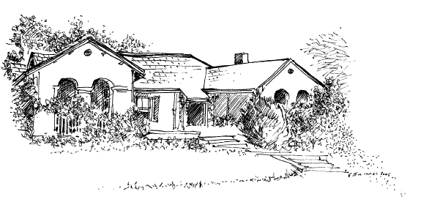
Information about Calthorpes’ House

The following information provides both an introduction to Calthorpes’ House and to Dawn Calthorpe. This may be information you would like to share with your students in preparation for their visit to Calthorpes’ House.

Calthorpes’ House was built in 1927, the year the Provisional Parliament House opened in Canberra. Dawn Calthorpe was three years old when they moved from Queanbeyan into the brand new house in the brand new city. Dawn lived at Calthorpes’ House until she grew up and got married, during the Second World War.

Dawn’s parents were Harry and Dell Calthorpe. Dawn had a sister whose name was Del. The Calthorpe family also lived with their maid, Mary. Dawn and Del had many pets to feed and play with. The cat’s name was Tiddles, the canary was Glad, and the dog was called Johnson.

In the book, Dawn’s Surprise, it is Del’s twelfth birthday. Dawn is not quite seven. Del’s birthday is the 29 September and Dawn’s is the 15 December. Del now lives in Queensland and Dawn still lives in Canberra.

The truly unique feature of Calthorpes’ House is that everything in the house actually belonged to the Calthorpe family. The question of what is real and what is a reproduction is not a factor. The connection between the story, Dawn’s Surprise and the student’s exploration of the house is immediate, for example, the pianola really is the one Del and Dawn played when they were children.

Checklist for planning your excursion:

- Please Note: Dawn’s Surprise relies on the students being familiar with the story book that accompanies this program which can be downloaded from our website. A copy will also be posted once you have a confirmed booking. Please read the book to your students. You are welcome to keep the book you have been sent, to copy it for educational purposes, and extra copies are available.

- Clothing: Calthorpes’ House programs are indoor and outdoor excursions that involve walking. Warm, waterproof attire is important in the cooler months and sun protection is also a priority throughout the year. Calthorpes’ House backs onto Red Hill and due to the possibility of snakes long pants and closed toed shoes are required. It is recommended visiting Teachers are familiar with the ACT Government Territory and Municipal Services Living with Snakes information, particularly the section Avoid being bitten, which can viewed at the following location: http://www.tams.act.gov.au/parks-recreation/plants_and_animals/urban_wildlife/local_wildlife/snakes. Calthorpes’ House retains the right to refuse entry to students who are inadequately dressed.

- Weather: The programs are offered in all weather. Some alternative activities can be provided indoors. The decision to postpone lies with the school. If you decide to postpone your booking, please ring 6207 9943 and 0424 585 464 as soon as possible so we can notify the presenters. If a catastrophic fire danger rating is issued by ACT Emergency Services or a severe weather warning is issued by the Bureau of Meteorology the program will be cancelled by the ACT Historic Places Education Officer.

- Student preparation for the excursion: Divide the class into groups of 10 with at least one adult for each of these smaller groups.

- Name tags: Please ensure that every student wears a name tag. This allows the presenters to communicate more effectively with the students.

- Lunch: It is best that students do not bring school bags as they cannot take these on the program. Lunches should be collected into a few tubs. On arrival your presenters will show you where to put your food. It is recommended that students drink fluids during breaks. There are no bins provided, please take your rubbish away with you. If undertaking a combined program with Calthorpes’ and Mugga-Mugga lunch will be at Mugga.

- First Aid Kit: Please bring a First Aid Kit. Please note that our First Aid Kit does not include medications, nor can we supply equipment for allergic reactions such as an EpiPen. Please ensure you bring with you any medicines your students should require while they are at Calthorpes’ House.

- Special Needs: Please advise the Bookings Officer at the time of booking if there are students in your group with special needs or access considerations including sight / hearing / physical / learning / allergies or who will be accompanied by a learning support assistant so staff can be prepared to assist in appropriate ways and vary the program as necessary.

- Numbers: Please confirm with the Education Officer the total number of students who attend the program on the day.

- Risk Management Plan: Please check the Risk Management Plan for Dawn’s Surprise, available from our website at the following link - http://www.museumsandgalleries.act.gov.au/calthorpes/education.html

What will happen during the program?

Arrival: Your bus will not be able to enter the grounds of Calthorpes’ House, as the driveway is too narrow. Please disembark on the nature strip on the Calthorpes’ House side of the Mugga Way. The road is quite busy and the museum is just below a crest, therefore we recommend students do not cross Mugga Way to access the Museum. When you have disembarked the group will be directed to make their way along the driveway to the Garage at the rear of the house. You will be met by the presenters who will introduce the program to the class.

During the program: After the introduction the students will be split into the small groups of 10 students. Each group should be accompanied by at least one adult. The group will all do the same program in a different order.

There are three rotations:

The House: The focus of this rotation is the book, Dawn’s Surprise. The students tend to recognise rooms and items from the book and will visit the same rooms as Dawn.

Before entering the house, students and accompanying adults will be required to put covers (booties) over their shoes. This helps to protect and conserve the floor coverings. The presenter and teachers should ensure booties are secure around students’ ankles so as to reduce risk of tripping on excess fabric. The presenter will wear white gloves to handle collection items. Students will handle one or two items from the Education Collection and it will be made clear at all times which items may be handled and which may not.

The Garden: The garden at Calthorpes’ House simply invites exploration. Students will be guided around the different sections of the garden, including the formal garden, play areas, vegetable garden and two orchards. This rotation is significant given the strong sensory focus on smells and physical observation of the garden.

Games: Students will play the same games that Del and Dawn played when they were young. These could include:
  - Quoits, marbles and hopscotch;
  - sack races; and
  - egg-and-spoon races.

Please note: The focus year of this program is 1931 – the year Dawn turned seven. The air raid shelter is not an intrinsic part of the program, as it was built about ten years later. Please let the Education Officer know prior to your visit if you would like your students to visit the air raid shelter during the program. The air raid shelter is not accessible during the snake season, from October to March.

Pre visit activity

Dawn’s Suitcase: Dawn’s suitcase contains objects that relate to her childhood in the late 1920s and 1930s. Unlike the collection at Calthorpes’ House these objects can be handled and used by your class as they are objects from our Education Collection, representative of their time, rather than artefacts from Calthorpes’ House. They offer an excellent link to the objects your students will see at Calthorpes’ House.

Please note: Some of the items in the suitcase are SHARP – such as the razor, hat-pins and the money box. Please supervise your students at all times.

Dawn’s suitcase is available free of charge to local schools. Please ring 6205 0916 to organise your loan. Please bring the suitcase when you come with your class to Calthorpes’ House, alternatively, return it to Canberra Museum and Gallery on the corner of London Circuit and Civic Square.

Suggestions for use:
- When you first open the suitcase, ask your students to work out what all the different items are for. The answers range from the very easy, like the book, gloves etc to more difficult, like the hat-pins and the soap saver.
- Encourage your students to handle the items and experiment with their use – under supervision and as appropriate.
- Discuss all the items in the context of program concept, the same, yet different.

Items in the suitcase may include:

Yoyo: Dawn remembers that yoyos were very popular at school. She and her friends spent many hours practising in order to impress each other. How is this yoyo the same yet different from the ones of today?

Knucklebones: Knucklebones was another popular children’s game. But these are real bones. Watch out for the knucklebone if you eat roasted leg of lamb. How is this different from the toy knucklebones sold today?

Picture puzzle: While your students try to piece the different pictures together, suggest that they look out for a similar one in Dawn’s bedroom at Calthorpes’ House.

Jig-saw: This jig-saw is typical of the ones Dawn loved as a child. How is it the same yet different from the jig-saws of today?

Map puzzle: This one is a copy of the original one in Dawn’s bedroom at Calthorpes’ House. What places can your students identify on the map?

Commonwealth Bank Money Box: There are lots of opportunities to discuss the same yet different here. The Commonwealth Bank still makes similar money boxes, but with one significant difference. The money boxes today have a hole and a replaceable seal on the bottom, so savings can be taken out at any time. The money boxes in Dawn’s time could only be opened with a tin-opener (this encouraged children to be more vigilant with their saving). Has this one been opened? Could you re-use it as a money box?
Please note: SHARP EDGES.

Embroidered apron: Young girls were taught to embroider at school. Dawn remembers embroidering an apron similar to this one. It shows the kind of stitches she was required to learn and practise.

Tea infuser: Seven year old Dawn would never have heard of a tea bag. This is because tea bags are quite a recent concept. How do you think tea was made with the infuser? The infuser was the only alternative to making a whole pot of tea for just one person.

French Knitting, hair-pin and wool: This will be particularly useful if you do the post-visit French Knitting activity. Your students are welcome to add a few stitches – you may need to add extra wool.

Soap saver: Soap savers were used before the development of dishwashing liquid. Leftover pieces of soap were placed inside and swished around in the washing-up water to make it soapy. Watch out for the soap saver hanging over the kitchen sink at Calthorpes’ House.

Book – Among the Horses: This is a children’s story produced in Great Britain. Note the structure of the book: black text and pictures with occasional coloured prints. Look at the quality of the illustrations as well as what is depicted in them, e.g. clothing, changes in technology, etc. How does it compare with the books of today?

Hat-pins: Hat-pins were used to hold a woman’s hat firmly to her head. The pins went through her hat to attach to her hair, and stopped it falling off when it was windy. They also allowed the hat to be placed at a jaunty angle without falling off. Maybe this could be demonstrated with a school hat. How do we keep our hats on today?
Please note: SHARP

Gloves: Women like Mrs Calthorpe would never have left the house without gloves. These ones are made of kid, and would have been worn on special occasions. Watch out for the glove stretchers in the laundry at Calthorpes' House.

Embosser: There is an embosser just like this one in the dining room at Calthorpes’ House. The one in the suitcase actually belonged to another family, and we had the address changed to the Calthorpes’ address – 24 Mugga Way, Red Hill. No post code, why not?

Metal billy and ¼ pint measure: During Dawn’s childhood, milk was delivered by a milkman with a horse and cart. Dawn remembers hearing their arrival every morning as they passed her bedroom, going up the drive to deliver the milk at the back door. The milk was measured out into the Calthorpes’ billy using a pint scoop. How do you get your milk today? How much is a pint?

School satchel: Compare it with school backpacks. How much could you carry in this one?

Razor: This one is similar to Mr Calthorpe’s. How do men shave today?
Please note: SHARP

Writing implements for school:
Dipping pen: Try writing with it. Which way up does the nib go? Why would it be difficult to write left-handed? Please note: THE NIB IS SHARP

Penny bottle: Ink was made up from a powder mixed with water. Once the ink had been mixed, it would be stored in a little bottle like this one so that the dipping pen could be dipped easily.

Blotting paper: Why do you need to blot the page?

Photograph Album
This album contains photos that relate to the childhood of Del and Dawn at Calthorpes’ House.

- Del and Dawn standing outside the brand new house in 1927. Del is eight and Dawn is three.
- Calthorpes’ House in 1927, when it was brand new. Notice that so far there is no garden or driveway.
- Dawn on her tricycle.
- The opening of Parliament House, May 1927. The whole Calthorpe family attended the ceremony at the opening of Parliament House, when the Duke and Duchess of York opened the building.
- Building the house next door. This house was completed one year after the Calthorpes’. You can see the Calthorpes’ house in the background.
- On the steps outside the house. Dawn is sitting on the left-hand wall and her grandmother is on the right. Del is the right-hand child sitting cross-legged on the steps.
- This is the family car – a Buick – crossing the bridge over the Cotter River. Del is opening the door of the car.
- Del has just won the sand-castle building competition, and is sitting proudly in front of her masterpiece. Dawn’s sand-castle is on the left.
- Del and Dawn under a sprinkler in the garden. There is lots of opportunity to comment here on how things have changed. Do children still play under sprinklers, or are we more aware of wasting water? And look at the togs. That’s what Del and Dawn called them. What do you call them?
- Snow falling on the garden. How is the new garden getting on?
- Shopping at Kingston – at J. B. Young’s. Look at the interior of the shop and talk about the differences between shopping then and now.

7

Post visit activity

French Knitting: Here are some instructions for French Knitting. Dawn and Del were both very fond of this activity. Why not get your class busy knitting? Or simply discuss the last paragraph of the instructions! Would you write similar instructions today?
References
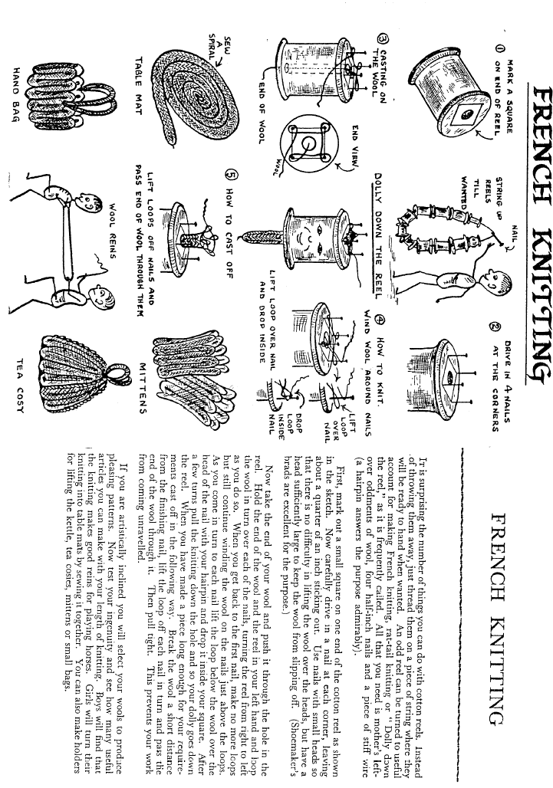

ACT Government, 2010-current. Hazard and OHS Risk Assessment form: Dawn’s Surprise. Downloadable from: http://www.museumsandgalleries.act.gov.au/calthorpes/education.html

ACT Heritage Council. 2001 Calthorpes’ House Entry to the ACT Heritage Register. Downloadable from: http://www.tams.act.gov.au/__data/assets/pdf_file/0003/13359/232.pdf.

Australian Curriculum and Assessment Reporting Authority. 2013. Australian Curriculum: History. Downloadable from:
http://www.australiancurriculum.edu.au/History/Rationale

Bickford, Anne. 2003. Calthorpes’ House. Cultural Facilities Corporation, Canberra.

Burness, Elizabeth Pickhaver. Illustrations. In Jo Pillinger, Dawns’ Surprise. ACT Museums and Galleries, Canberra.

Gibbney, James. 1986. Calthorpes’ Canberra: The Town and Community in 1927. Calthorpes’ House Museum: occasional series no. 1. Australian Government Publishing Services, Canberra.

Lawson, Elaine. 1993. Calthorpes’ House: Notes on the house, contents and Conservation philosophy.

Waterhouse, Dawn. 2002. Chortles, Chores and Chilblains: Cameos of Childhood in Calthorpes’ House, Canberra. ACT Historic Places, Cultural Facilities Corporation, Canberra.

